dml_Cdml_Creation

Kate.Rovinski

5/12/2020

#R Markdown Document to Document Code Generation # From Shiny App output CSV files per MOATs to database creation

# Table of Contents

# A.) Review of Project (Dates & Settings)

# B.) Repository Information

# C.) Version Check

# D.) Libraries needed

* segments of code -

# 1.) Working Directory

# 2.) Spolling Data into one CSV

# *this includes insitu samples # 3.) Creating the Dataframe “dml” # 4.) Creating dateTime objects # 5.) Creating Treatment Variables # 6.) Creating Night and Day Periods # 7.) Cleaning up dml “Cdml” # 8.) Framing the filters - Cdml # 9.) Temperature Jump flag logic # 10.) Calculating averages by treatment & day/night # 11.) Summary & Group by Cdml # 12.) Plots # 13.) Duration between conditions- time above/below mean #* this is the histogram section

# X.X) Share-able tibbles… for putting on stackoverflow :(

# A.) Review of Project (Dates & Settings)

Krill collected the nights of September 9-10th 2019. Acclimation period ended 20SEP19. System ramped to treatment conditions from 20SEP19 to 23SEP20. Animals considered under treatment from 23SEP19 to 30OCT19.

# B.) Repository Information

Script is saved under the repository: “KROVINSKI/ NWFSC.MUK_KRL_SMR2019 / 06. MOATS replication verification / 02. Scripts”

URL to Repository ( <https://github.com/KROVINSKI/NWFSC.MUK_KRL_SMR2019.git> )

## File Size Limitations

1. GitHub has a 5GB limit. Sharedrive, OA drive, contains the most complete back up of raw data files

* Link to OA Drive ( <https://drive.google.com/open?id=16pxVWFifuHKQURGbd4HxL0rqgkgWqzI8> )

1. Repository with labview’s LVM files and the shiny app output files are located in KROVINSKI/ NWFSC.MUK_MOATs_SMR2019/LabViewLogs.AllMOATS/

* Subfolders broken down by MOATs
* Link to repository ( <https://github.com/KROVINSKI/NWFSC.MUK_MOATs_SMR2019.git> )

# C.) Version Check

Intial code was built on R 3.6.1 (Action-of-the-Toes) {r #********************************* ## Version Check #********************************* R.version}

This is an R Markdown document. Markdown is a simple formatting syntax for authoring HTML, PDF, and MS Word documents. For more details on using R Markdown see <http://rmarkdown.rstudio.com>.

When you click the **Knit** button a document will be generated that includes both content as well as the output of any embedded R code chunks within the document. You can embed an R code chunk like this:

summary(cars)

## speed dist   
## Min. : 4.0 Min. : 2.00   
## 1st Qu.:12.0 1st Qu.: 26.00   
## Median :15.0 Median : 36.00   
## Mean :15.4 Mean : 42.98   
## 3rd Qu.:19.0 3rd Qu.: 56.00   
## Max. :25.0 Max. :120.00

## Including Plots

You can also embed plots, for example:

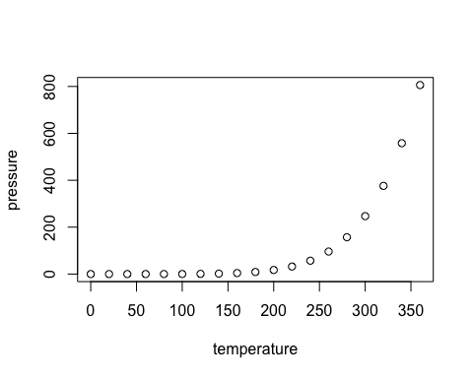

Note that the echo = FALSE parameter was added to the code chunk to prevent printing of the R code that generated the plot.